SMS
Admin App
User Module
Login Use Case

Actors | Responsibilities
Administration User | Login to the administration portal

Design:

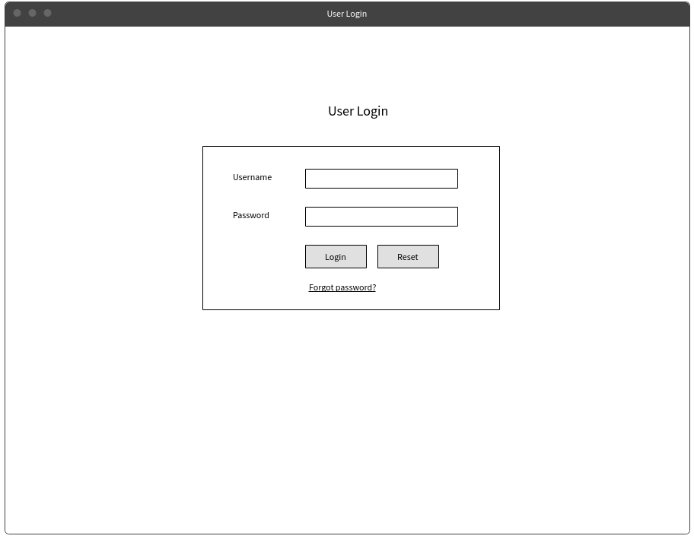

On Success:

Action | Data
Redirect | User Dashboard

On Failure:
Action | Data
Show Message | Invalid Username or Password

Services:
Operation | Service Reference Number
Form Submit | SERVICE_0001

